3. Instrument Details
3.1. Instrument Manufacturer
Beckman Coulter
http://www.beckmancoulter.com/
3.2. Instrument Model
MoFlo Astrios integrated to Baker Hood
Serial number: AV12013
Manufactured: March 2013
Pre-shipment QC: completed before July 2013 (Moflo), 04/26/13 (Baker Hood)
3.3. Instrument Configuration and Settings
3.3.1. Fluidics
This is a jet-in-air cell sorter.
3.3.2. Light Sources

Pinhole 1: 640-nm Newport Corporation, model EXLR-640C-105-219, solid state; 105mW
Pinhole 2: 488-nm Coherent, solid state; 200mW
Pinhole 3: empty
Pinhole 4: 561-nm MPB Communications, model VFL560V3, solid state; 200mW
Pinhole 5: empty
Pinhole 6: 405-nm Newport Corporation, model EXLR-405C-55-219, solid state; 55mW
Pinhole 7: 355-nm JDSU solid state; 100mW, SNF608364
3.3.3. Excitation Optics Configuration
The Laser engine houses all lasers except for the 355nm. They are delivered to pinholes via fiber optic and their alignment in relation to one another is fixed. These lasers utilize top-hat optics. The UV laser is stand-alone laser, using Gaussian Beam Shaping Optics and focused manually to the pinhole position.
3.3.4. Optics Filter
The instrument received the EQ upgrade on February 24, 2015, which included dual PMTs for FSC discrimination and a 200mW laser for 488nm.
The instrument can accept optical configuration changes. Refer to the attached configurations found in 3.3.5 Optical Detectors

3.3.5. Optical Detectors
Installation configuration is listed below for each laser detection pod.
Optical Detectors are modular.
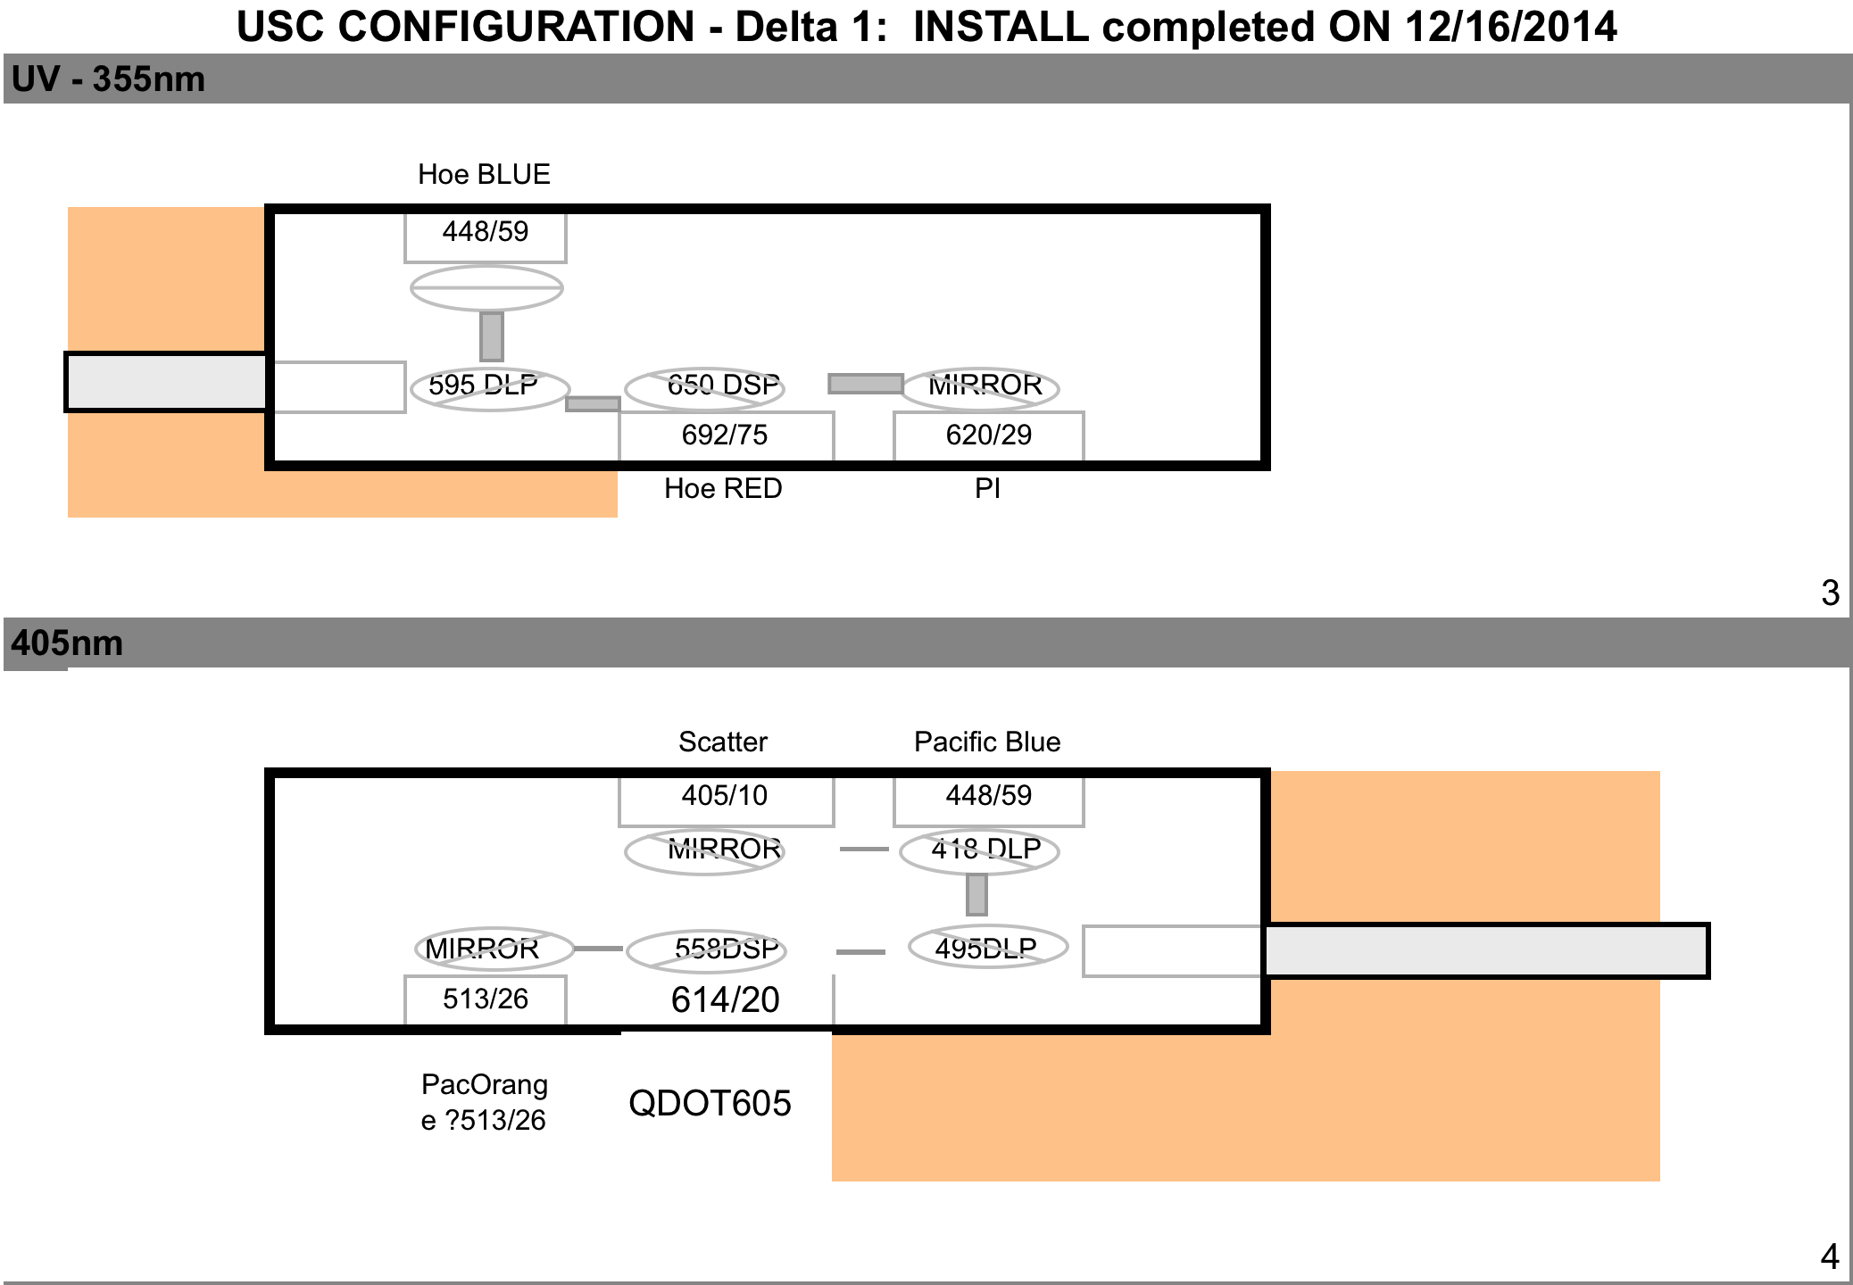

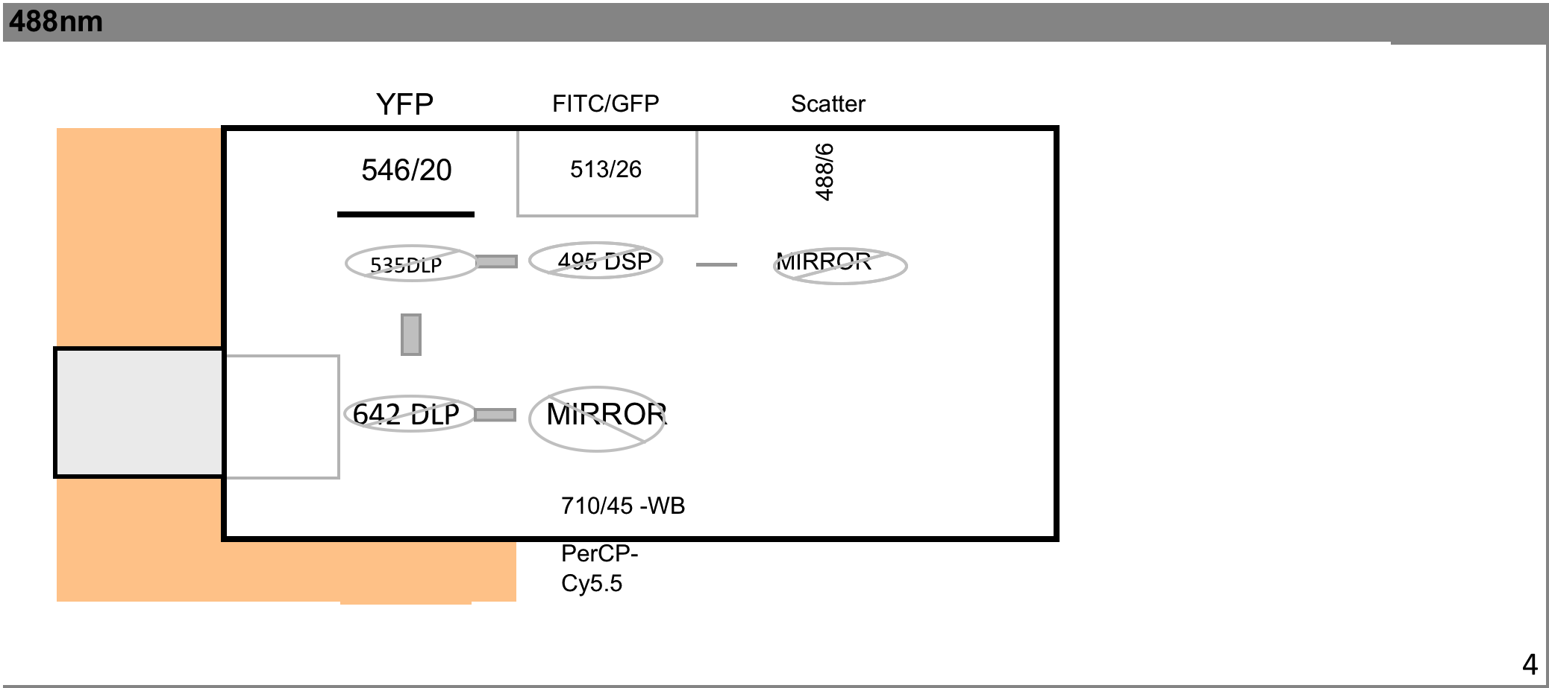
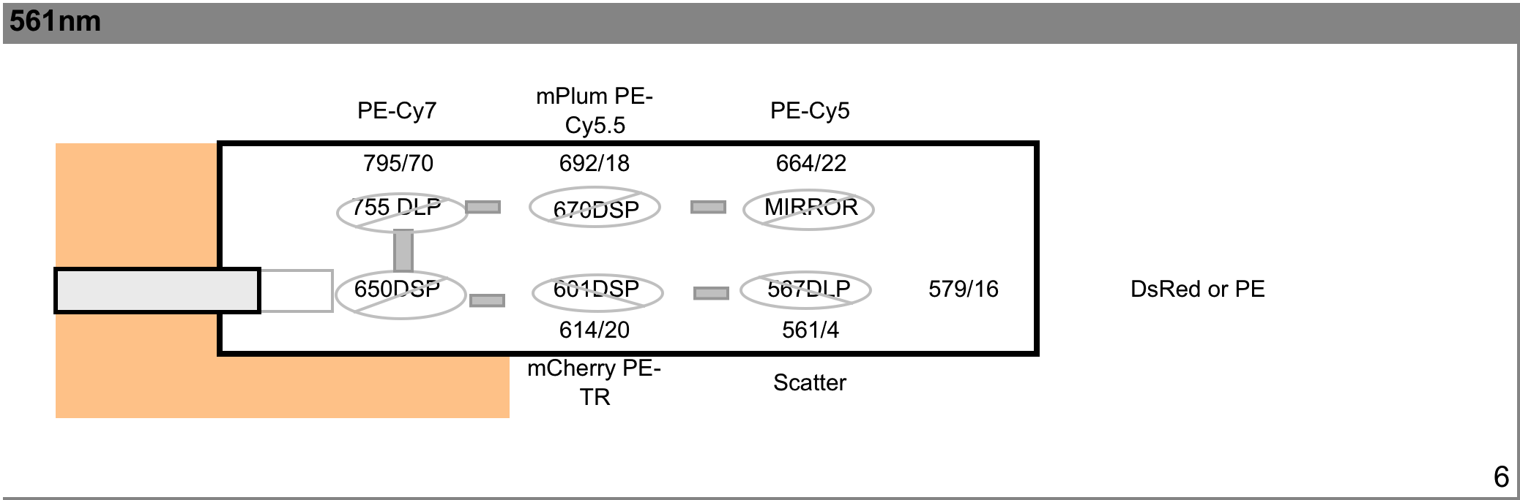
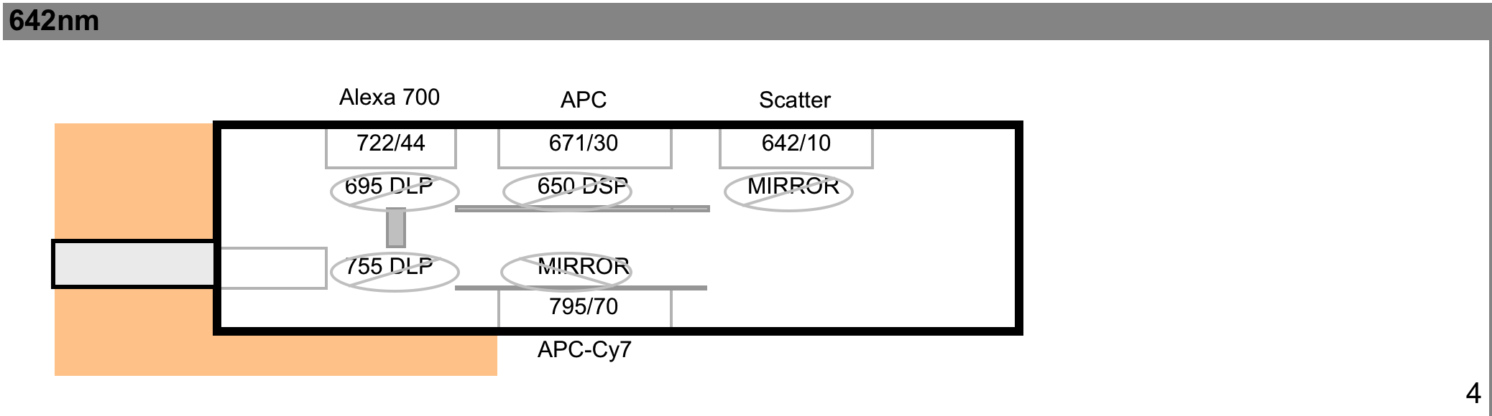

3.3.6. Optical Paths
Optical filters are removable.

3.4. Other Relevant Instrument Details
- MoFloAstrios User’s Guide: PN# B22986C Astrios IFU
- Summit Software v.6.2.7.16492 installed 2/24/15

